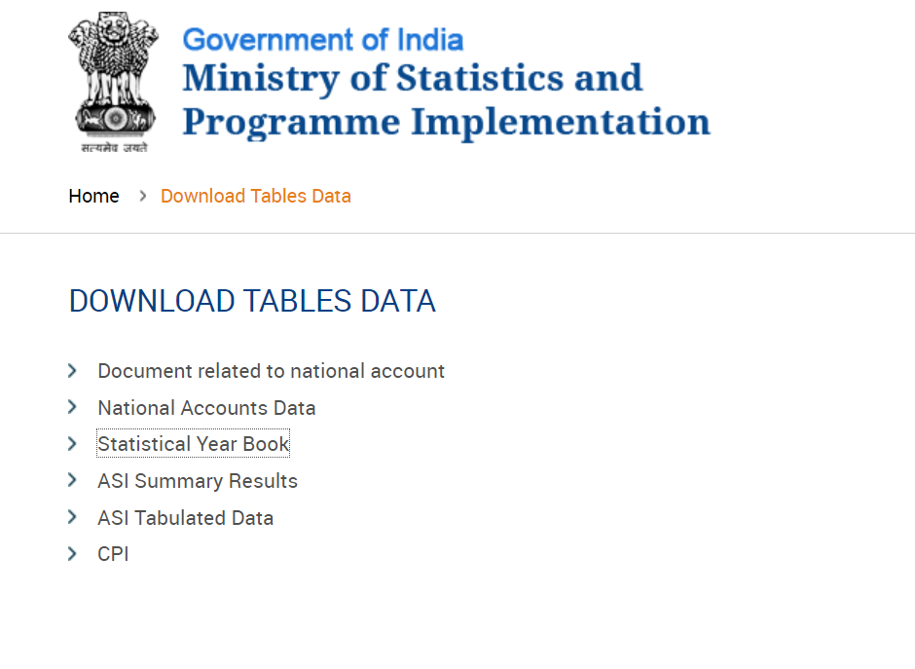

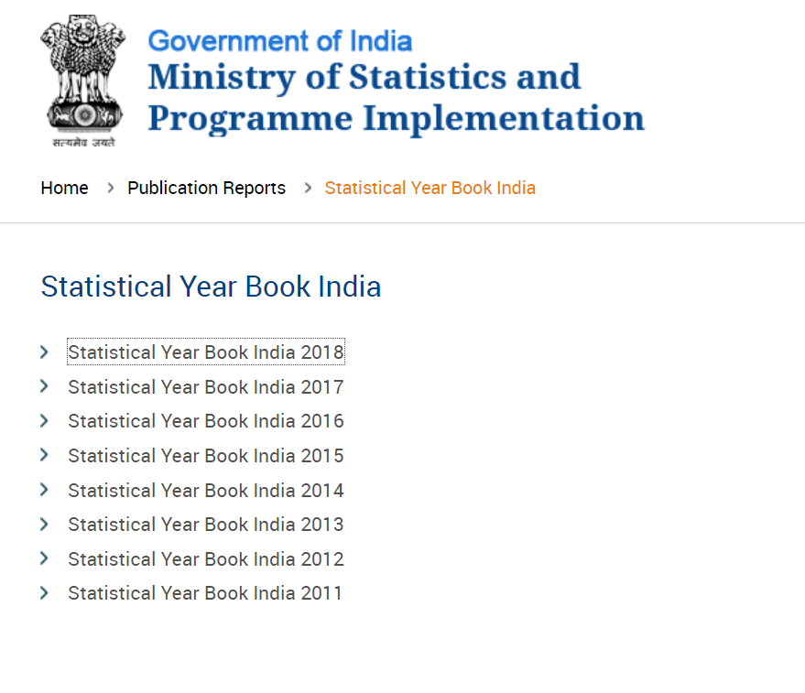

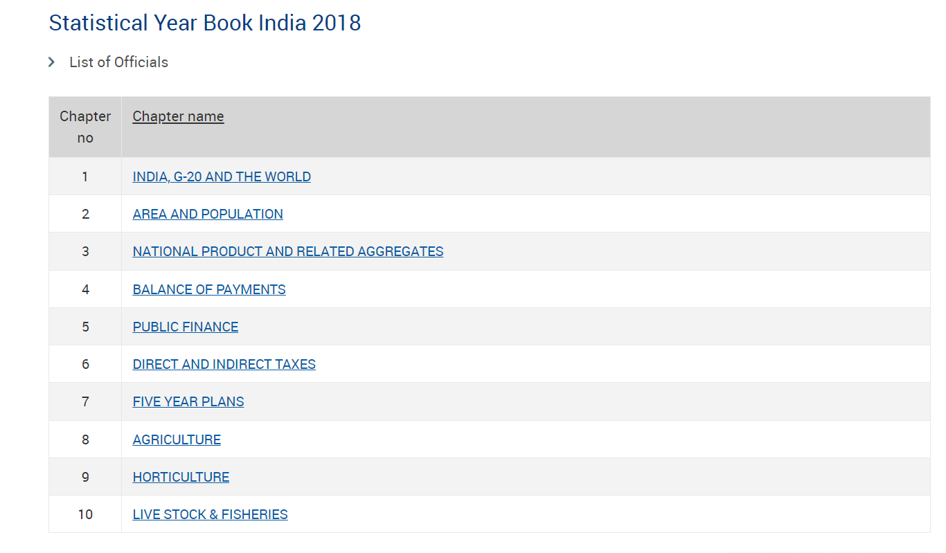

1. Compute Karl Pearson’s coefficient of correlation

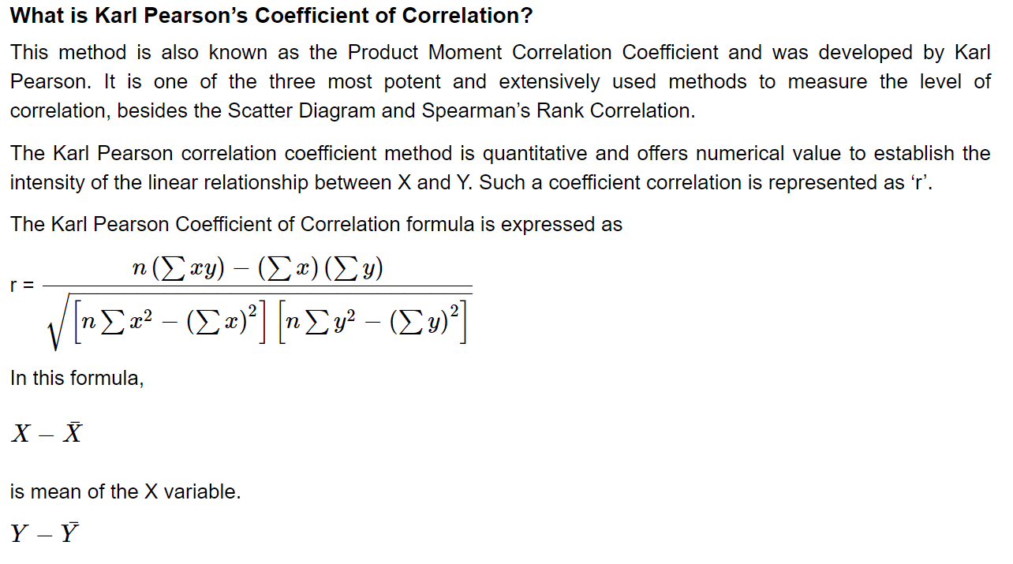

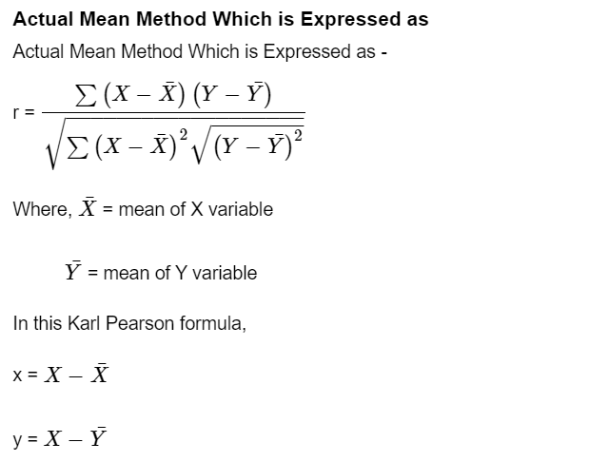

Data SET

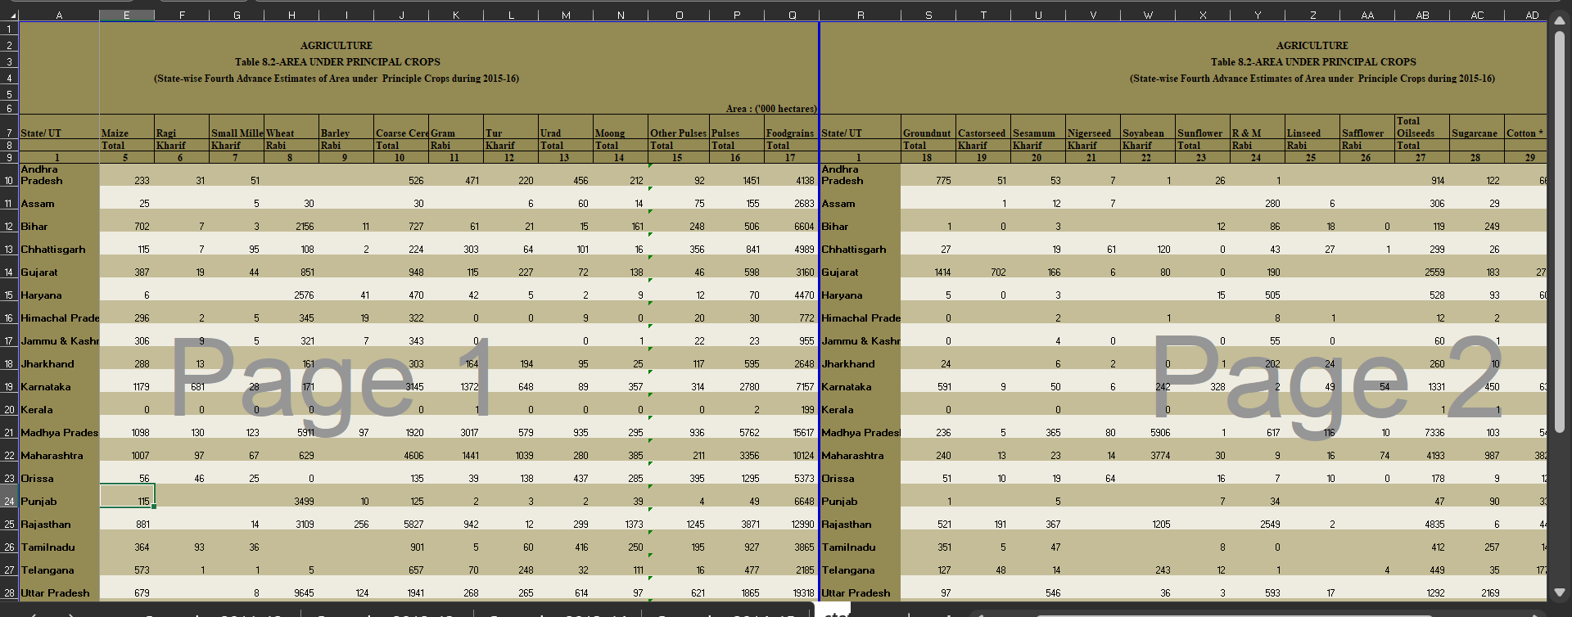

FINAL DATASET:

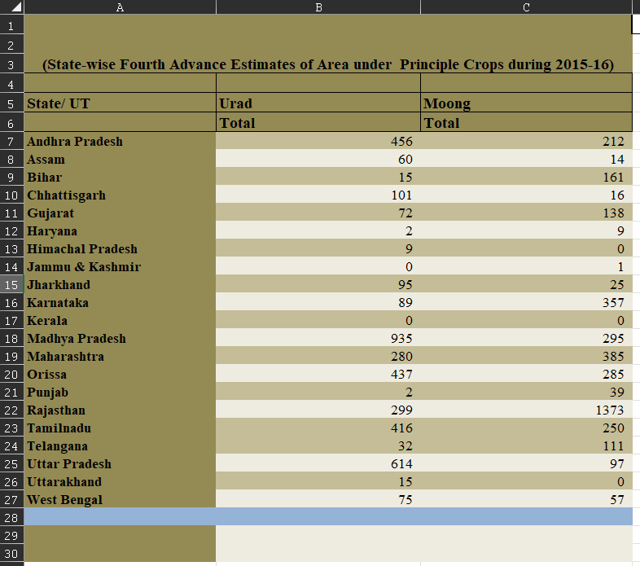

Calculation performed:

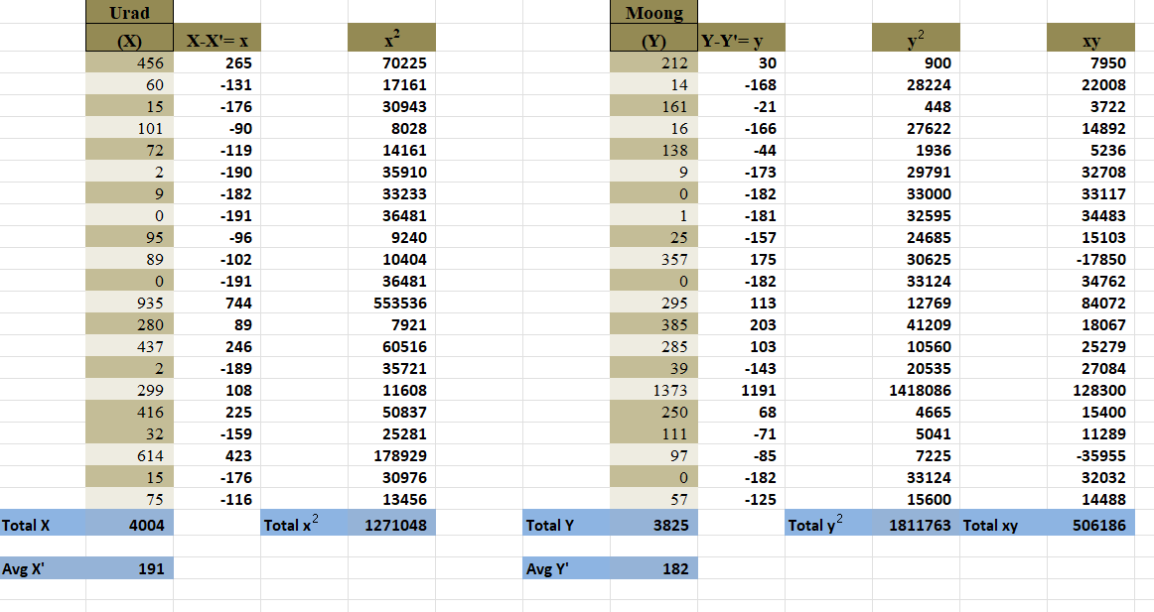

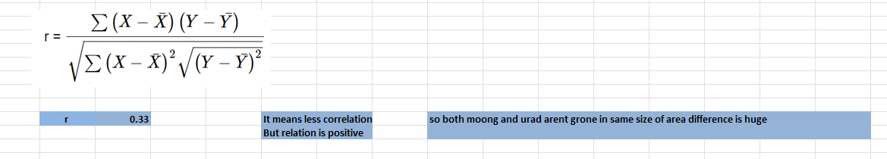

>> Correlation is less as coefficient is near to 0. But relation between both crops groth is similar in all states.

>> Area of farming differs eventually as correlation is less.

R = 0.33

R is Karl Pearson’s coefficient of correlation

1. Compute Spearman’s rank correlation.

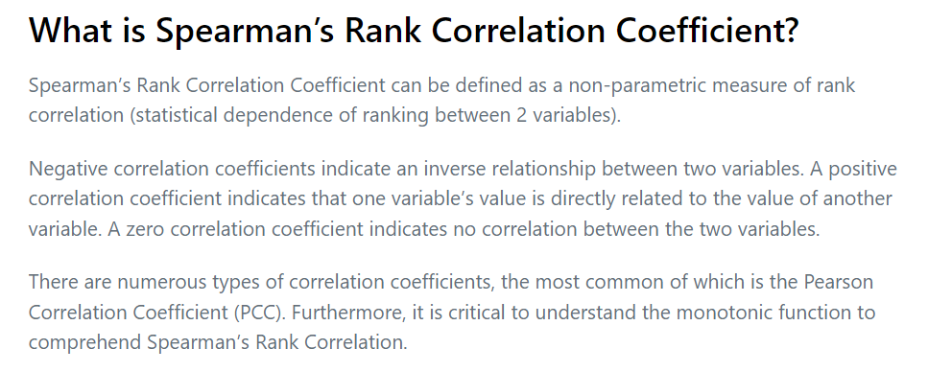

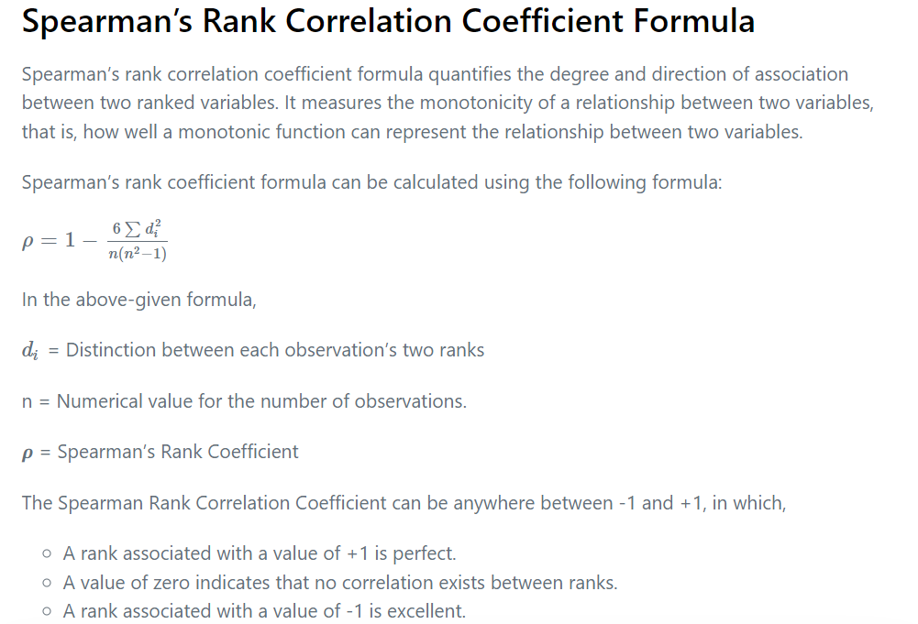

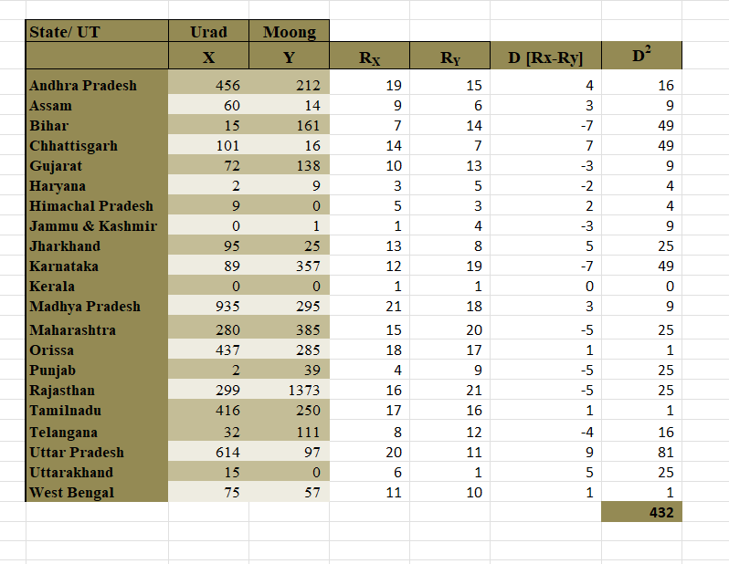

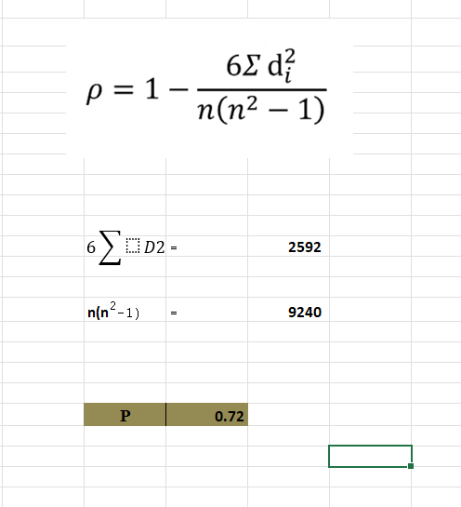

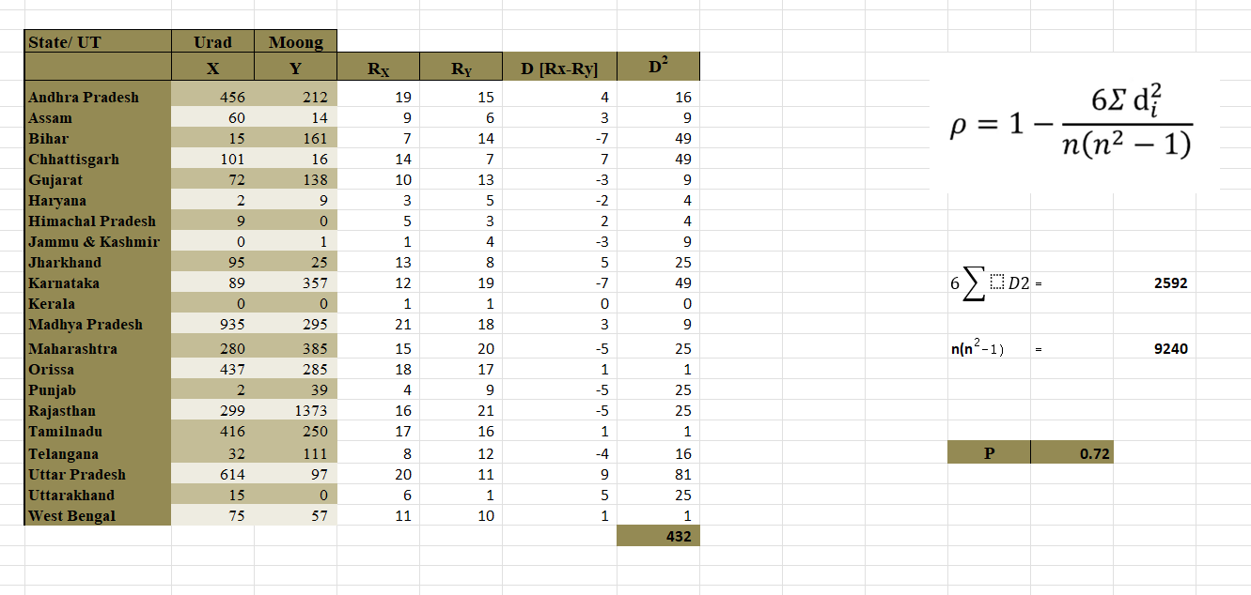

P = 0.72

P is highly correlated as value is near +1.

And relation of ranks is positive too!

P is Spearman’s rank correlation.

1. Briefly interpret the outcome by comparing the coefficient of correlation of the datasets.
2. Remember that Spearman's correlation determines the strength and direction of the monotonic relationship between your two variables rather than the strength and direction of the linear relationship between your two variables, which is what Pearson's correlation determines. Linear relationships are straight line relationships.  Monotonic relationships differ from linear relationships in that the two variables might converge, but not at a constant rate.

Correlation coefficients are indicators of the strength of the [linear relationship](https://www.investopedia.com/terms/l/linearrelationship.asp) between two different variables, x and y. A linear correlation coefficient that is greater than zero indicates a positive relationship. A value that is less than zero signifies a negative relationship. Finally, a value of zero indicates no relationship between the two variables.

The possible range of values for the correlation coefficient is -1.0 to 1.0. In other words, the values cannot exceed 1.0 or be less than -1.0. A correlation of -1.0 indicates a perfect [negative correlation](https://www.investopedia.com/terms/n/negative-correlation.asp) and a correlation of 1.0 indicates a perfect [positive correlation](https://www.investopedia.com/terms/p/positive-correlation.asp). If the correlation coefficient is greater than zero, it is a positive relationship. Conversely, if the value is less than zero, it is a negative relationship. A value of zero indicates that there is no relationship between the two variables.

1. We got,

Karl Pearson’s coefficient of correlation as 0.33 means relationship is positive but weak.

So linearly they aren’t that much corelated and hence area of farming of moong and urad dal aren’t grown equally in different part of india.

Spearman’s rank correlation as 0.72 means have strong monotonic relationship.

So monotonically they are strongly correlated and hence farming of both dal successfully done in required season.

Karl Pearson's coefficient of correlation at 0.33 signifies a positive yet weak relationship between the areas of moong and urad dal farming in various parts of India. This suggests that while there is a positive association, it's not particularly strong in a linear sense, explaining the unequal growth of these crops across different regions. Conversely, Spearman's rank correlation, marked at 0.72, indicates a robust monotonic relationship between the two types of dal farming. This stronger correlation implies that there's a consistent and strong association between the farming of moong and urad dal, allowing for successful cultivation of both crops in their respective required seasons.